 |  | 
Placing children’s rights at the heart of all we undertake.
respect integrity humility equality care towards all

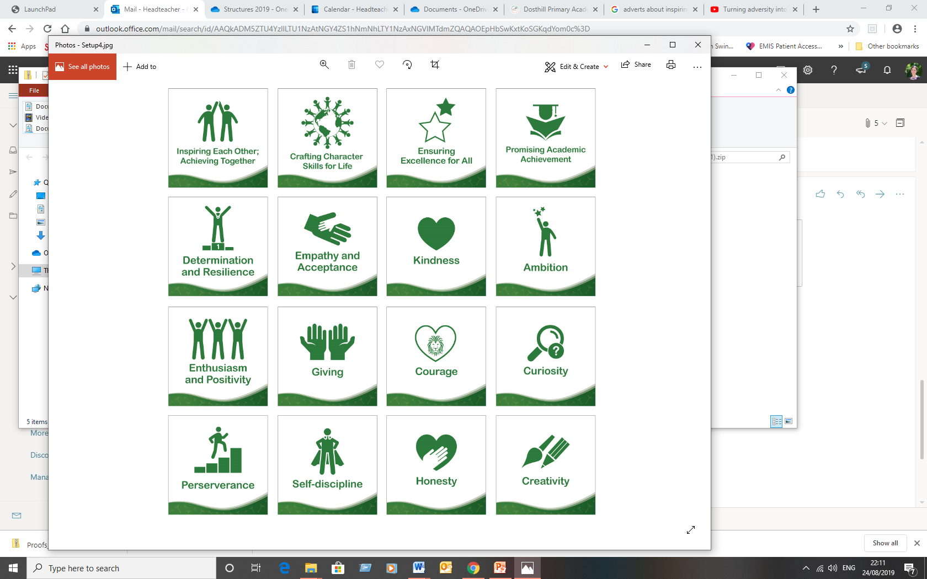

Dosthill Primary Academy
Remote Learning Policy
Rationale
In the event of a full school closure, the school is committed to providing a continuity of education to its learners. This will be provided through remote (online) learning. Extensive remote learning would apply particularly in a situation in which the school is closed for an extended period of time, but a high proportion of students and teachers are healthy, and able to work as normal from home.
Remote learning may also be appropriate in situations when students, in agreement with the school, have a period of absence but are able to work at home, at least to some extent. This may apply in cases such as exclusion from school, or longer term illness, assuming students are able to complete school work at home.

Who is this policy applicable to?
In line with the Governments National Lockdown restrictions all learners will access remote learning unless they are attending school as a critical worker or vulnerable child.
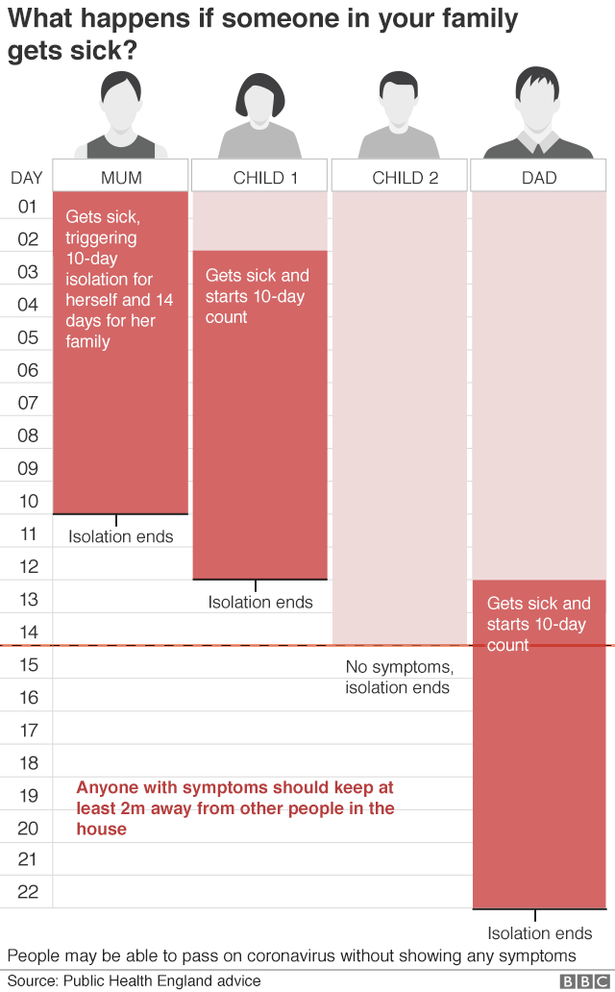
In line with government guidance, pupils, staff and families who are attending school should self-isolate if they display any of the following symptoms;
- A continuous, dry cough
- A high temperature above 37.8℃
- A loss of, or change to, their sense of smell or taste
- Have had access to a test and this has returned a positive result for Covid-19
Flexibility of Learning
We realise that the circumstances that cause our school to close or of a family having to self-isolate will affect families in a number of ways. In our planning and expectations, we are aware of the need for flexibility from all sides:-
- parents may be trying to work from home so access to technology as a family may be limited;
- Parents may have two or more children trying to access technology and need to
prioritize the needs of young people studying towards GCSE/A Level accreditation;
- teachers may be trying to manage their home situation and the learning of their own
children;
- systems may not always function as they should.
An understanding of, and willingness to adapt to, these difficulties on all sides is essential for
success. All learning that is pre-recorded will be available to view at any time. This will also support the learners at home who can re watch lessons/modelling to support their on-going learning.

Often, it is necessary to operate more flexibly, for example to accommodate contexts where pupils are having to share a single device within the home, meaning that access to recorded lessons is also needed. However, frequent contact between pupils and teachers is crucial. This contact may, for example, be through presence in a remotely delivered lesson, questioning, feedback, or some other form of on or offline exchange about schoolwork. (DFE 2020)

Devices are available from the DFE in the first instance for disadvantaged learners but can be offered to other families who are in need of a device to access their remote learning.

SEN learners
It is the expectation of the school to provide learners with SEN targets differentiated learning within the live lessons and a 1:1 live lesson once per week.
SEN learners will be provided with their own private channels within the class teams page. Within this page their class teachers will be able to share learning and videos to support their SEN targets.
Once a week, at a designated time, a session will be shared 1:1 with the learner to address a specific target. Within this process learning will be provided through pre-recorded video, live chat and photo modelling.

Expectation for families
We believe that it is in the best interests of our children that we continue to provide structured support to the best of our ability. It must be noted that the work children engage in during a period of closure will be part of our current planning and so should not be considered as optional. Children and parents should consider the arrangements as set out in this document as highly recommended. Where families have made school aware they have no devices for online learning, alternative arrangements have been made. (Appendix 6)

For school closures

Parents will:-
- Will follow the instructions given by school and ensure they do not send their child/children into a school setting during the closure.
- Support their child’s learning to the best of their ability.
- Contact the school through the correct channels if there are any concerns or support is needed. (1: Call the school office. 2. Email the school office. 3. Email Mrs Nicholson 4. Email Mrs Keay)
- Ensure that children have access to the learning provided by the school.

Teaching Staff will :-
- Provide learning closely linked to the school’s medium term plans to ensure no lost learning.
- Provide 3 pre-recorded video introductions for Mathematics/English per day and one Curriculum per week.
- Provide learning that can be completed both online and offline.
- Provide feedback for learning that is returned on Teams or Tapestry. (Appendix 5)
- Respond to queries within the hours of 9am – 12noon each day. Providing live commentary for learning during this time. This will be on the Learning Challenges Page.
- Contact children daily either through Teams (on-line chat) or where necessary through a telephone conversation.
N.B The staff member providing the learning and giving the feedback may not always be the class teacher.

Children will:-
- Follow the class time table for their learning at home e.g;
9 – 9:30 – Daily exercise (e.g. Joe Wicks)
9:30 – 10:30 – Maths (pre-recorded video available daily)
10:30 – 10:45 – Break
10:45 – 11:30 – English (pre-recorded video available daily)
11:30 – 12:00 – Grammar (KS2) or Phonics (Early Years and KS1)
12 – 1pm – Lunch (Staff will not be available for chat during this time)
1pm – 1:30pm – Daily reading
1:30pm – 3pm – Curriculum based learning linked to topic (One pre recorded video will be available for the week)
- Ensure that learning they are completing is to the best of their ability.
- Only access materials that have been shared by teaching staff or by parental permission.
- To only use Teams or Tapestry to contact members of their class or teachers in an appropriate manner.

Learner well-being
Learner well-being and mental health is highly important to us as a school community. As a result, we have thought carefully about the elements we have in place to support learners who are learning remotely.
- Once a week a mental health assembly will be shared from an outside agency to support with well-being during the National Lockdown.
- A keeping in touch page is available on all Class Teams Pages (Year Two -Six) for children to talk to their friends from their classes. This is monitored daily by staff members.
- Phone calls are made to families who are vulnerable on a weekly basis to check in.
- Phone calls are made weekly to children in Reception and Year One to keep in contact and provide support.
- A worry box is available on the school website and through the class Teams pages. This is checked by members of SLT daily.

Expectation for staff working remotely during school closures
Teachers
- Provide learning closely linked to the school’s medium-term plans to ensure no lost learning.
- Provide pre-recorded video introductions for Mathematics, English per day and one Curriculum where appropriate.
- Follow guidelines outlined in appendix (1) for any pre-recorded videos.
- Follow guidelines outlined in appendix (2) and (3) for learning and chat expectations.
- Provide learning that can be completed both online and offline.
- Provide feedback for learning that is returned on Teams or Tapestry. (5)
- Respond to queries within the hours of 9am – 12noon each day. Providing live commentary for learning during this time. (see appendix 2 and 3)
- Contact children daily either through Teams (on-line chat) or where necessary through a telephone conversation. To keep a class communication log. (Appendix 4)
- EYFS and Year One to contact all children once a week by telephone, with a class communication log being kept. (Appendix 4)
- Assessing the needs of the learners and responding to these as they would within class. Tracking of gaps and learning to take place as part of AfL for all lessons that are taught “live”.
- Follow normal safeguarding procedures during the school closure.
- If they are unable to work for any reason during this time, for example due to sickness, they should report this using the normal absence procedure.

Teaching Assistants
- Teaching assistants, who are not in school, must be available between 9am and 3pm each day to support with marking and feedback. In the afternoon, when the class teacher is preparing the following day they must monitor Teams.
- During the school day, teaching assistant must complete tasks as directed by a member of the SLT.
- If they are unable to work for any reason during this time, for example due to sickness, they should report this using the normal absence procedure.

Subject Leaders
English, mathematics and Curriculum leads are responsible for:
- Setting out the expectations for each year group.
- Providing advice and guidance to support staff.
- Signposting useful resources to support the planning of remote learning.
- Ensure that remote learning is of a high standard and consistent across the school through discussing the learning available with maths planners and viewing this together.
- If they are unable to work for any reason during this time, for example due to sickness, they should report this using the normal absence procedure.

The IT lead is responsible for:
- Provide training and support for all staff to support remote learning.
- Monitor remote learning set.
- Monitor Class Teams chat.
- Provide technical support for parents and children, including passwords.
- Provide regular updates to parents regarding the procedures.
- Fixing issues with systems used to set and collect work
- Helping staff with any technical issues they’re experiencing
- Reviewing the security of remote learning systems and flagging any data protection breaches to the data protection officer
- Assisting pupils and parents with accessing the internet or devices
- If they are unable to work for any reason during this time, for example due to sickness, they should report this using the normal absence procedure.

Teaching, Learning and Standards Leaders in conjunction with subject leaders and IT
Alongside any teaching responsibilities, Teaching, Learning and Standards Leaders are responsible for:
- Checking the remote learning approach across the school including daily monitoring of engagement from pupils.
- Monitoring the effectiveness of remote learning –through regular discussions with teachers and subject leaders, reviewing work set and reaching out for feedback from pupils and parents.
- Monitoring the security of remote learning systems, including data protection and safeguarding considerations
- If they are unable to work for any reason during this time, for example due to sickness, they should report this using the normal absence procedure.

Designated safeguarding lead
- The DSL is responsible for managing and dealing with all safeguarding concerns raised by staff or parents.
- If they are unable to work for any reason during this time, for example due to sickness, they should report this using the normal absence procedure.

Inclusion leader/Assistant SENCO

- Liaising with parents of children who have an EHC plan to discuss needs and adjustments required for remote learning.
- Ensuring that pupils with EHC plans continue to have their needs met while learning remotely, and liaising with the headteacher and other organisations to make any alternate arrangements for pupils with EHC plans.
- If they are unable to work for any reason during this time, for example due to sickness, they should report this using the normal absence procedure.

Staff Absences
Who is absent | Who covers | Implications
Staff member leading a pod | A reserve member of staff who is teaching remotely | The remote learning will need to be led by other members of that year group for the period in which the reserve member of staff is covering a pod.
Staff member in Reception or Year One | Other members of the team ensure the learning is shared on Tapestry.  A member of the team would need to make phone calls to the class. | If videos have not been pre-recorded the staff members would need to make these for the core subjects for the period in which the member of staff is absent.  Phone calls to be made by the members of the Team.
Staff member in Year Two | Other members of the team ensure the learning is shared on Teams.  A member of the team would need to make phone calls to the class.  If on members of Year Two staff are available BN to lead. | If videos have not been pre-recorded the staff members would need to make these for the core subjects for the period in which the member of staff is absent.  Phone calls to be made by the members of the Team.
Staff member in Year Three to Six | Other members of the team ensure the learning is shared on Teams.  If no members of the Year group staff are available, TA’s to be deployed to support. BN to monitor. | If videos have not been pre-recorded the staff members would need to make these for the core subjects for the period in which the member of staff is absent.
Subject leaders or SLT are absent | Other members of SLT/WLT will support in the monitoring of curriculum and learning remotely.
IT lead is absent | SLT to support staff. RB and SMcH to provide the technical support to SLT and parents. | RB and SMcH may need to be onsite to support with this.  SLT to complete daily communication checks.
DSL is absent | DSL’s would cover this amongst other members of the Team and ensure duty days were shared out. | If all DSL were unavailable TH to be contacted.

Remote learning systems access information
Reception
- Reception learners will use the Tapestry App to access learning and documents provided by the class teachers linked to the suggested time table.
- Parents will upload evidence of the learning completed at home.
- They will have also have access to Numbots https://play.numbots.com/#/intro
- Log in details will be provided on Tapestry for this.
- Parents should continue to read with their children;
- Songs, rhymes and opportunities to talk should be maximised;
- Practical activities such as baking, painting and craftwork should also be undertaken.

Year One
- Year One learners will use the Tapestry App to access learning and documents provided by the class teachers linked to the suggested time table.
- Parents will upload evidence of the learning completed at home.
- They will have also have access to Numbots https://play.numbots.com/#/intro and Reading Eggs https://readingeggs.co.uk/
-Log in details will be provided on Tapestry for this.
- Parents should continue to read with their children;
- Songs, rhymes and opportunities to talk should be maximised;
- Practical activities such as baking, painting and craftwork should also be undertaken.

Year Two
- Year Two learners will access learning using the Class Teams page.
- One live lesson per day will be completed.
- Assignments will be shared with pre-recorded videos for the other learning throughout the day.
- Parents will support the learners in uploading their learning.
- Learners will have access to Numbots https://play.numbots.com/#/intro and TT Rockstars https://play.ttrockstars.com/auth/school/student and Reading Eggs https://readingeggs.co.uk/
- Learners will have access to Active Learn; https://www.activelearnprimary.co.uk/login?c=0
- Parents should continue to read with their children;
- Practical activities such as baking, painting and craftwork should also be undertaken.

Year Three
- Year Three learners will access learning using the Class Teams page.
- Two live lessons per day will be completed.
- Guided Reading will be set as a stand along assignment.
- Parents will support the learners in uploading their learning.
- Learners will have access to TT Rockstars https://play.ttrockstars.com/auth/school/student and Reading Eggs https://readingeggs.co.uk/
- Learners will have access to Active Learn; https://www.activelearnprimary.co.uk/login?c=0
- Parents should continue to read with their children;
- Practical activities such as baking, painting and craftwork should also be undertaken.

Year Four
- Year Four learners will access learning using the Class Teams page.
- Three live lessons will be available each day with the option to complete assignments at different times if necessary.
- Parents will support the learners in uploading their learning.
- Learners will have access to TT Rockstars https://play.ttrockstars.com/auth/school/student and Reading Eggs https://readingeggs.co.uk/
- Learners will have access to Active Learn; https://www.activelearnprimary.co.uk/login?c=0
- Parents should continue to read with their children;
- Practical activities such as baking, painting and craftwork should also be undertaken.

Year Five
- Year Five learners will access learning using the Class Teams page.
- Three live lessons will be available each day with the option to complete assignments at different times if necessary.

- Parents will support the learners in uploading their learning.
- Learners will have access to TT Rockstars https://play.ttrockstars.com/auth/school/student and Reading Eggs https://readingeggs.co.uk/
- Learners will have access to Active Learn; https://www.activelearnprimary.co.uk/login?c=0
- Parents should continue to read with their children;
- Practical activities such as baking, painting and craftwork should also be undertaken.

Year Six
- Year Six learners will access learning using the Class Teams page.
- Three live lessons will be available each day with the option to complete assignments at different times if necessary.
- Parents will support the learners in uploading their learning.
- Learners will have access to TT Rockstars https://play.ttrockstars.com/auth/school/student
- Learners will have access to Active Learn; https://www.activelearnprimary.co.uk/login?c=0
- Learners have access to Reading Eggs; https://readingeggs.co.uk/signup1/
- Parents should continue to read with their children;
- Practical activities such as baking, painting and craftwork should also be undertaken.

Online resources recommended by School
- BBC daily lessons https://www.bbc.co.uk/bitesize/dailylessons
- Oak National Academy https://classroom.thenational.academy/
- Phonics Play https://www.phonicsplay.co.uk/
- Youtube Kids https://www.youtubekids.com/
- Think You Know (Online Safety) - https://www.thinkuknow.co.uk/
- White Rose Home learning https://whiterosemaths.com/homelearning/
Appendix 1

When creating a video for online/remote learning it is recommended that you use FlipGrid.
These guidelines must be followed to safeguard yourself and the learners.
Failure to follow these guidelines could result in disciplinary action.

When videoing at home ensure that;
- Backgrounds are blank, with no family photographs or distinguishing features.
- If recording yourself, ensure professional clothes are worn.
- Ensure you watch videos back to check for any mistakes.
- When recording you should be the only person in the room.

Videos should be no longer than 5 minutes.

Videos should be, unless organised by SLT, of the class teacher of that class team.

Videos may be checked by SLT or other members of the leadership team at any time.

For more information about how you can safeguard yourselves and the children when remote learning;
https://www.gov.uk/guidance/safeguarding-and-remote-education-during-coronavirus-covid-19

Appendix 2
It is important to note that high quality remote teaching is far more than setting work for pupils to complete, although setting tasks to complement sequences of teaching plays an important role. Evidence shows that lengthy or open-ended projects or research activities are in most cases less likely to lead to strong progress or outcomes. Such approaches should generally be avoided in favour of the more interactive, teacher-led approaches to delivering the school’s planned curriculum described above. (DFE 2020)

In the event of a full closure learning will look as follows on Teams;
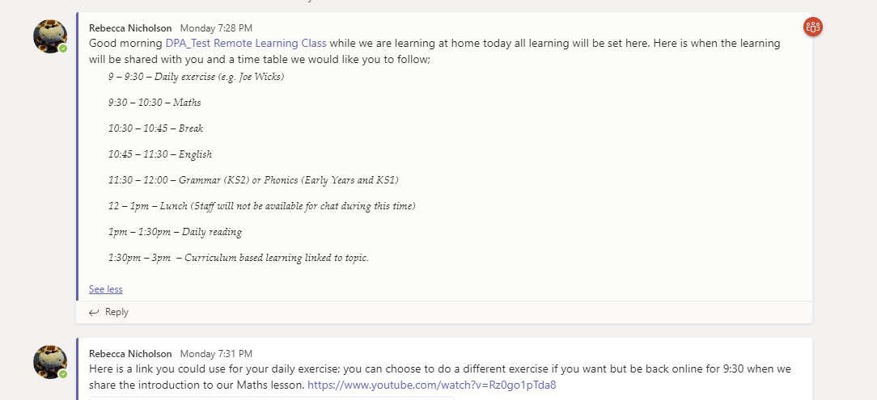
A morning message must be sent by 9am with the outline for the day
Maths and English must take place in the morning when the teacher is available for lessons. Teachers must be online between 9 – 12noon with an hour lunch 12 -1pm. By being online you will be able to adapt learning and respond to questioning to support learners.
A maths lesson may look like this;
Starter
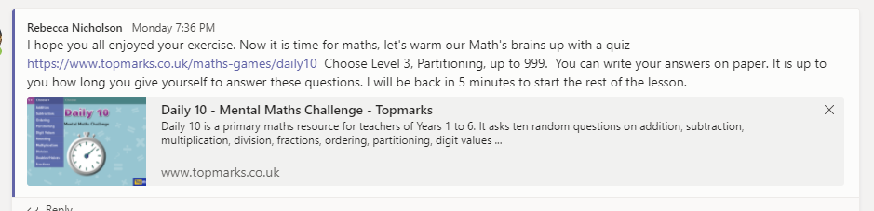
Introduction of learning challenge
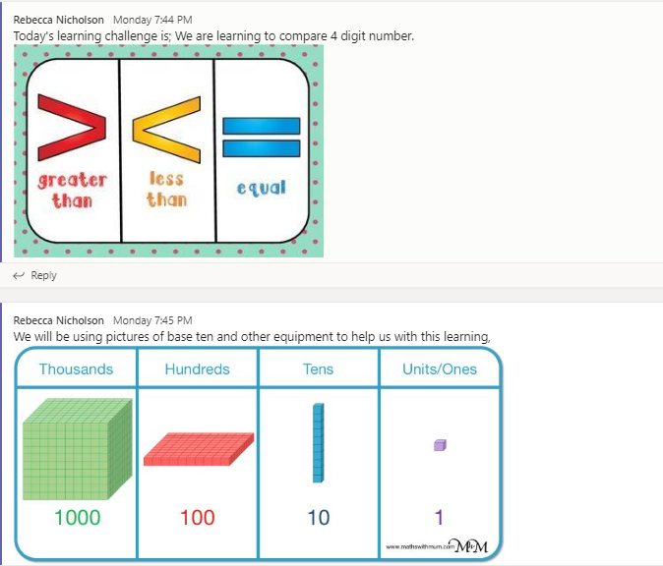
Introduction video (these can be no longer than 3 minute)
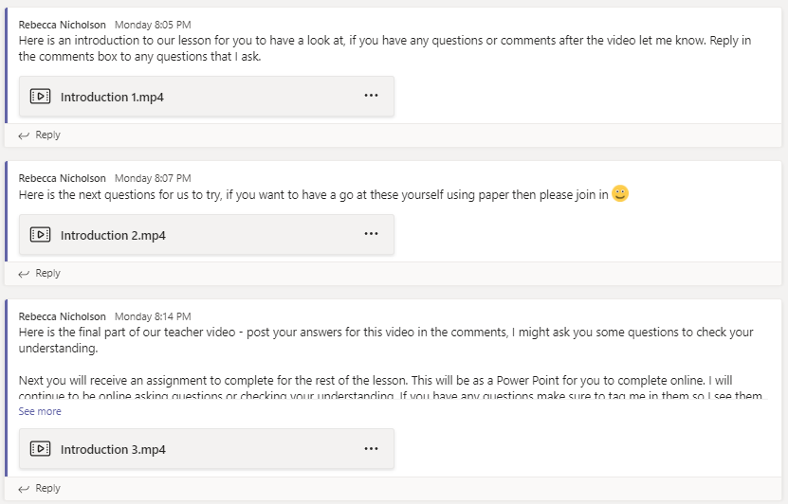
Set the learning
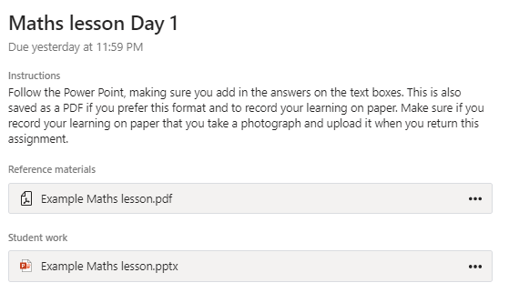
It is recommended that you have the assignment prepared in drafts and select assign when the learners are ready. Please ensure you are providing differentiated tasks as part of the learning.
Throughout the lesson you can ask questions, put in polls etc to engage learners. They can also ask you questions if they are stuck.
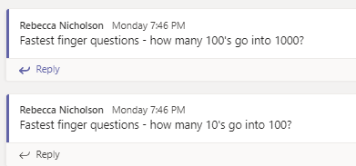

An English lesson may look like this;
Starter
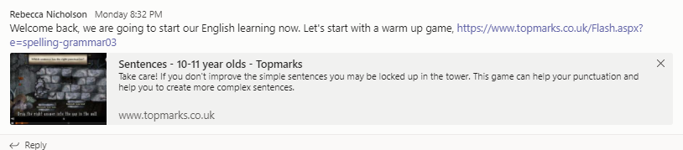
Introduction of learning challenge
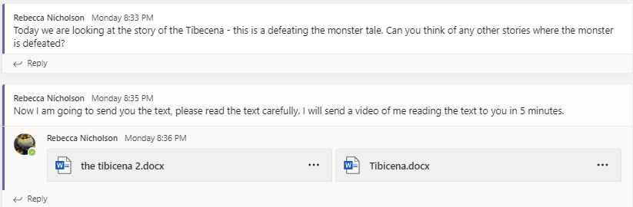
Introduction video (no longer than 3 minutes)
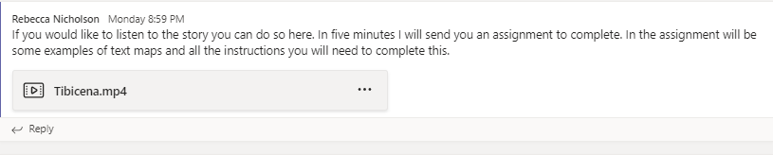
Set the learning

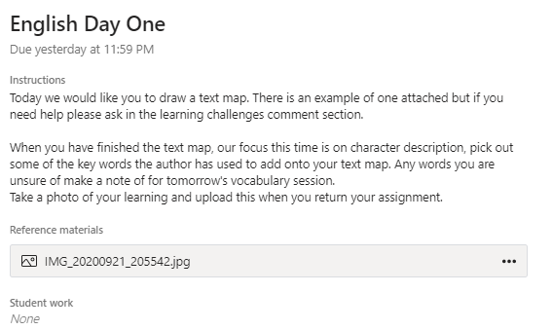
It is recommended that you have the assignment prepared in drafts and select assign when the learners are ready.
Throughout the lesson you can ask questions, put in polls etc to engage learners. They can also ask you questions if they are stuck.

For grammar learning it may look like this;
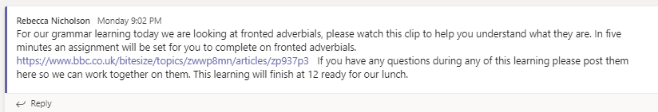
Engage with the children through chat during the session.
NB – Year Two will need to provide a phonics session for their learners instead of just grammar. This can be from Ruth Miskin’s YouTube channel or their own video activities.
Set the learning
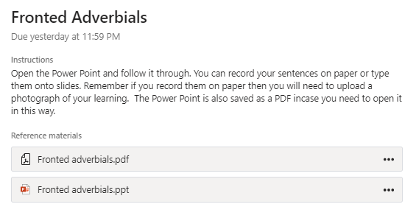
Daily reading may look like;
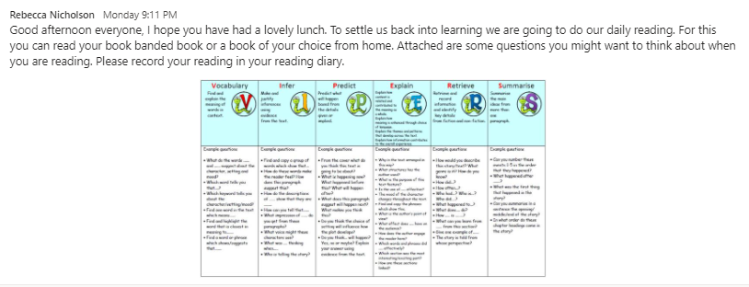
Curriculum learning may look like this;
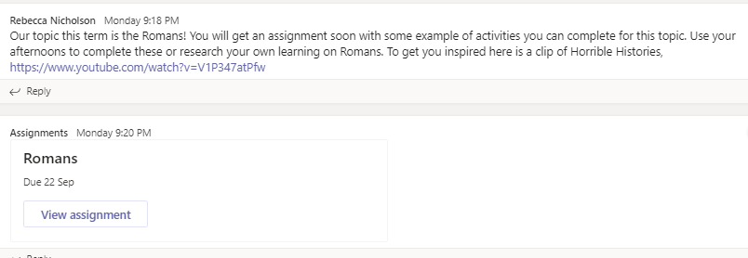
Other messages you may share in teams;
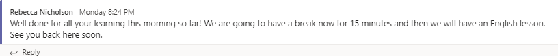
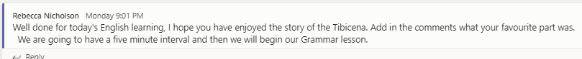
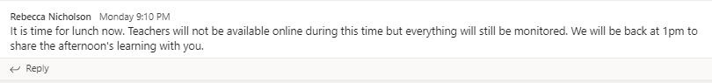

Appendix 3

In the event of a full closure learning will look as follows on Tapestry;

For Reception and Year One
Activities to be set daily by 9am for maths, English and phonics. A memo will be sent by 9am to outline the learning and expectations for the day. 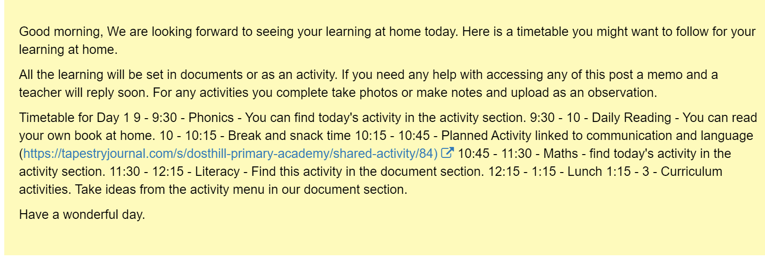
Example time table .

You can add new activities to the collection if none of the activities are suitable for the learners. It is expected that class teacher provide video modelling as part of the activities they are creating.

Appendix 4
Class communication records for Reception to Six must be completed daily by teaching staff and teaching assistants.
SLT will monitor the class communications daily for Year 3 – 6 and weekly for Year R - 2. All safeguarding concerns must be reported separately and not on the class communication.
If children are handing in assignments but not active in the live lesson make them yellow.
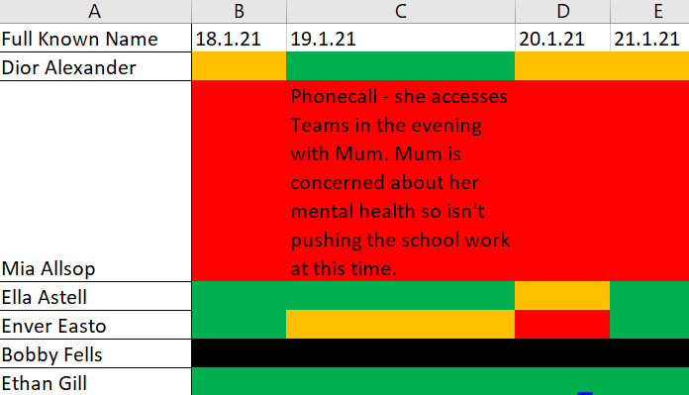
If children are live make them green.
If children are not active on Teams or handing in assignments make them red.

For Reception, Year One and Two class communication will be primarily through phone calls. A timetable will be provided for all staff (provided by CM and BN)
If items are uploaded on to Tapestry/Teams or you have made a phone call and spoken to the family make the box green.

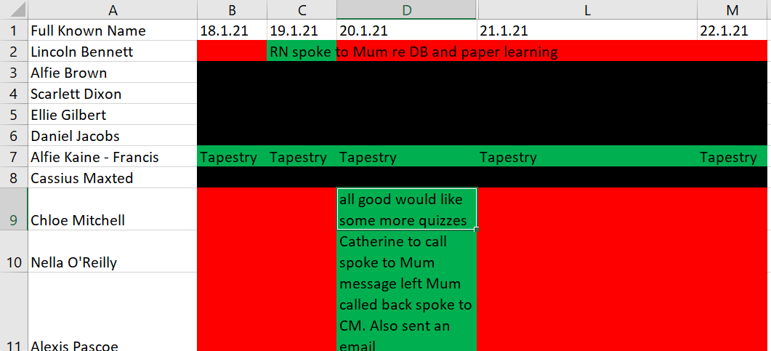
If no contact is made and no Tapestry items are uploaded make the box red.

When making phone calls from home ensure that you are alone with no family members in the room. All phone calls made must be from private numbers or the school phone. You can change this in your settings on your mobile device.

Appendix 5
Feedback examples to ensure responsiveness in a closure.

Feedback would be immediate during the “live lessons” through questioning. Polls would be encouraged to be used to assess learners. Other assessment tools could be Kahoot, quizzes etc. (Training for staff will be provided as part of a Professional Learning Session)

DFE have outlined some key points in the Remote Learning Good Practice document that can be found; https://www.gov.uk/government/publications/remote-education-good-practice/remote-education-good-practice

Live classrooms enable important interaction between teachers and pupils through, for example, questioning, eliciting and reflective discussion. (DFE 2020)

Assessing pupils’ progress
Teachers can use quizzes or tests on core content as a regular feature, asking pupils to complete these in a specified time and email them back. Using the features of a multi-functional platform, teachers can create regular, pre and post-lesson quizzes. Consideration should be given to ensuring availability for pupils without ready online access, including through distribution of hard-copy versions. (DFE 2020)

Examples
Polls
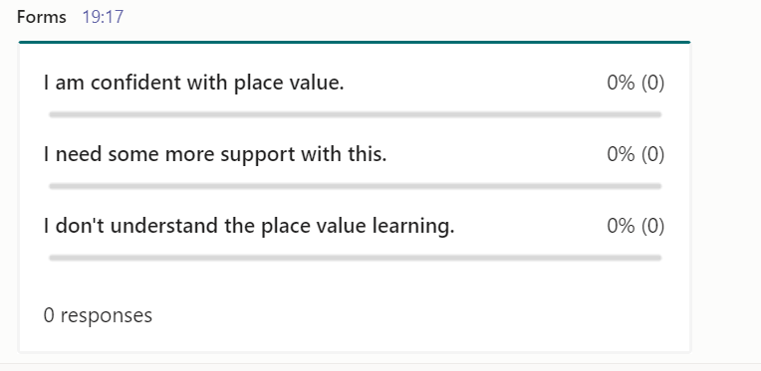 Staff would be expected to use this in the plenary part of their lesson to then support any learners who need extra intervention. Oak Academy videos may support these learners, or alternatively some modelling from the teacher can be sent to them as private assignments.

Where learning is set as an assignment the learning should be marked as it would be in school, with feedback provided to support the on-going learning. Staff should refrain from providing repetitive and non-specific feedback. Where learners are achieving the challenge, extra challenges can be given in the form of questioning or tasks. Learning should be differentiated as it would be in class to ensure all learners are able to access the challenge.
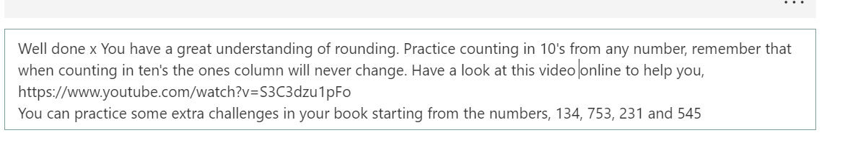

More examples will be provided for staff through out the academic year.

Appendix 6

Families with no devices for online learning.
All families have been sent a form to complete regarding devices at home. From this staff will be made aware of those learners in their year group. The IT lead and all of SLT have copies of this for all year groups.

School closure Learners

In the first instance an IPAD would be offered to the children who have no devices.
If this is not suitable for the family paper packs can be provided linked to the schools medium term plans.
It is not expected that this paper packs would contain the same learning that is completed online, but it should be expected that it links to the same objectives covered for the rest of the year group.

Appendix 7
What to do if….. | Action Needed | Return to school when…. | School actions
Child has one of these three symptoms  - New and persistent cough  - High temperature  - Loss of, or change in their normal sense of taste or smell | DO NOT COME TO SCHOOL  Contact school to inform us by 8am.  Arrange to have a test by calling 119 or visiting the NHS website.  The whole household self-isolate until you have had the results of your test. | ...the test comes back negative | School will offer learning on Teams from 11:30am and a timetable should be followed.  9 -9:30: Daily exercise (e.g. Joe Wicks)  9:30-10:00: Spellings; common exception words for your year group.  Use the strategy sheet to practise your spellings in different ways.  These can be found in the documents area of your class teams or Tapestry.  10 -10:15: Break  10:15- 11.00: TT Rockstars or Numbots  11-11:30: Home reading (Book banded book or reading for pleasure)  11:30-12:15: Grammar (KS2) or Phonics (Early Years and KS1)  12:15-1:15: Lunch  1:15- 2:15: Maths  2:15- 3:15: Curriculum based learning linked to topic.
Child tests positive for COVID 19 | DO NOT COME TO SCHOOL  Contact school to inform us  Agree an earliest date for possible return. Minimum of 10 days.  Self-isolate the whole household for 14 days  If they have tested positive whilst not experiencing symptoms but develop symptoms during the isolation period, they should restart the 10-day isolation period from the day they develop symptoms. | ...they feel better. They can return after 10 days even if they still have a cough or change/loss of smell as these symptoms can last for several weeks. | School works with local health protection team, identify those who have been in close contact with the student:  Close contact means:  *direct close contacts - face to face contact with an infected individual for any length of time, within 1 metre, including being coughed on, a face to face conversation, or unprotected physical contact (skin-to-skin)  *proximity contacts - extended close contact (within 1 to 2 metres for more than 15 minutes) with an infected individual  *travelling in a small vehicle, like a car, with an infected person  These people should self-isolate for 14 days since they were last in close contact with that person  Household members of those sent home do not need to self-isolate, unless the person who was sent home develops symptoms.  They should get a test if they show symptoms.  If the test shows negative they should still isolate for 14 days.  School will offer learning on Teams from 11:30am and a timetable should be followed (see above).
My child is ill with symptoms not linked to COVID-19 | FOLLOW USUAL SCHOOL ABSENCE PROCEDURE | If the absence is due to sickness or diarrhea, children can return after 48 hrs following the last bout of sickness
Someone in my household has COVID-19 symptoms | DO NOT COME TO SCHOOL  Contact school  Self-isolate the whole household for 14 days  Household member to get tested.  INFORM SCHOOL IMMEDIATELY ABOUT TEST RESULTS | ...the test comes back negative for the member of the household | School will offer learning on Teams or Tapestry from 11:30am and a timetable should be followed.  9 -9:30: Daily exercise (e.g. Joe Wicks)  9:30-10:00: Spellings; common exception words for your year group.  Use the strategy sheet to practise your spellings in different ways.  These can be found in the documents area of your class teams or Tapestry.  10 -10:15: Break  10:15- 11.00: TT Rockstars or Numbots  11-11:30: Home reading (Book banded book or reading for pleasure)  11:30-12:15: Grammar (KS2) or Phonics (Early Years and KS1)  12:15-1:15: Lunch  1:15- 2:15: Maths  2:15- 3:15: Curriculum based learning linked to topic.
Someone in my household tests positive for COVID-19 | DO NOT COME TO SCHOOL  Contact school  Agree an earliest date for possible return. Minimum of 14 days  If your child starts to have COVID-19 symptoms they should isolate for another 10 days from when the symptoms started. Contact school again to agree a date for possible return. | ...the child has completed the correct number of days of isolation | School will offer learning on Teams from 11:30am and a timetable should be followed.  9 -9:30: Daily exercise (e.g. Joe Wicks)  9:30-10:00: Spellings; common exception words for your year group.  Use the strategy sheet to practise your spellings in different ways.  These can be found in the documents area of your class teams or Tapestry.  10 -10:15: Break  10:15- 11.00: TT Rockstars or Numbots  11-11:30: Home reading (Book banded book or reading for pleasure)  11:30-12:15: Grammar (KS2) or Phonics (Early Years and KS1)  12:15-1:15: Lunch  1:15- 2:15: Maths  2:15- 3:15: Curriculum based learning linked to topic.
NHS track and trace has identified my child has been in close contact with someone with symptoms of confirmed COVID-19 | DO NOT COME TO SCHOOL  Contact school  Agree an earliest date for possible return. Minimum of 14 days  If they develop symptoms they must get a test.  If the test delivers a negative result they must still isolate for the remainder of the 14 days. | ...the child has completed 14 days of isolation | School will offer learning on Teams from 11:30am and a timetable should be followed.  9 -9:30: Daily exercise (e.g. Joe Wicks)  9:30-10:00: Spellings; common exception words for your year group.  Use the strategy sheet to practise your spellings in different ways.  These can be found in the documents area of your class teams or Tapestry.  10 -10:15: Break  10:15- 11.00: TT Rockstars or Numbots  11-11:30: Home reading (Book banded book or reading for pleasure)  11:30-12:15: Grammar (KS2) or Phonics (Early Years and KS1)  12:15-1:15: Lunch  1:15- 2:15: Maths  2:15- 3:15: Curriculum based learning linked to topic.
My child’s bubble is not in school due to a COVID-19 outbreak | DO NOT COME TO SCHOOL  At home, support your child with remote education provided by the school  Your child will isolate for 14 days.  If they develop symptoms they must get a test.  If the test delivers a negative result they must still isolate for the remainder of the 14 days. | ...school will inform you when the bubble will return to school. | School will provide learning for the first day of closure on Teams similar to that of the self-isolating absence.  From day 2, learning will be set live with the class teacher monitoring on Teams.  9 – 9:30 – Daily exercise (e.g. Joe Wicks)  9:30 – 10:30 – Maths (pre-recorded video available daily)  10:30 – 10:45 – Break  10:45 – 11:30 – English (pre-recorded video available daily)  11:30 – 12:00 – Grammar (KS2) or Phonics (Early Years and KS1)  12 – 1pm – Lunch (Staff will not be available for chat during this time)  1pm – 1:30pm – Daily reading  1:30pm – 3pm – Curriculum based learning linked to topic (One pre recorded video will be available for the week)

