Try:
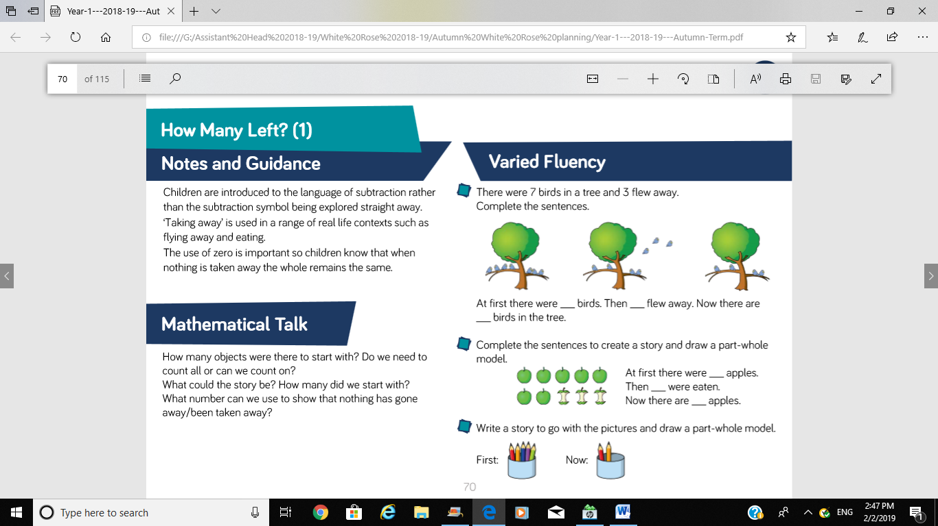

At first there were _______ pencils.
Then _______ pencils were used.
Now there are _______ pencils.

Try:
At first there were _______ birds.
Then _______ flew away.
Now there are _______ birds.

Try:
At first there were _______ apples.
Then _______ apples were eaten.
Now there are _______ apples.

