
Dosthill Primary Academy – Key Stage 1 Summer Home Learning

 | Reception | Year 1 | Year 2
Reading  (Research and read texts written by these Amazing Authors) | *Mick Butterworth  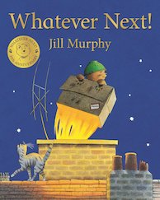  *Mini Grey  *Tony Ross | *Anthony Browne  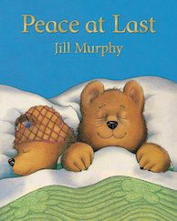  *Janet & Allan Ahlberg  *Enid Blyton | *Oliver Jeffers  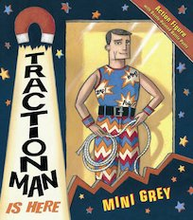  *Humphrey Carpenter  *Dick King-Smith
Writing | Write a shopping list. | Send a friend a postcard or letter. | Send a friend a postcard or letter.
Spelling  (see year group lists) | Can you spell the YR High Frequency Words? | Can you spell the Y1 High Frequency Words? | Can you spell the Y2 Common Exception Words?
Handwriting  (see cursive example) | Colouring  Playdough  Scissor skills using a pair of child-friendly scissors. | Colouring  Scissor skills using a pair of child-friendly scissors.  Practice your cursive writing | Start to join your writing using cursive script.
Mental maths | Number facts to 5  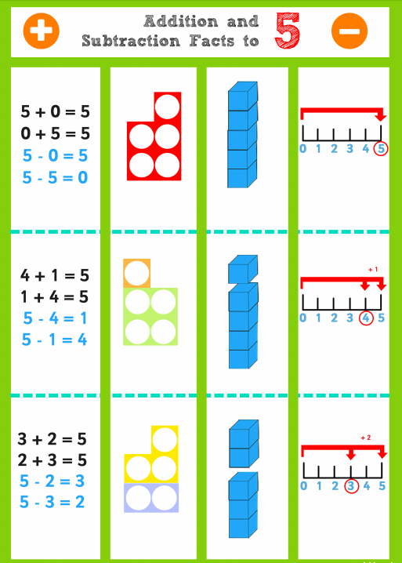 | Count forwards and backward from 100.  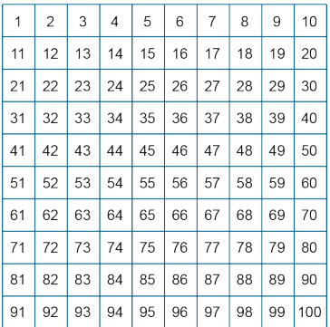 | Fluent addition and subtraction number facts for larger calculations.  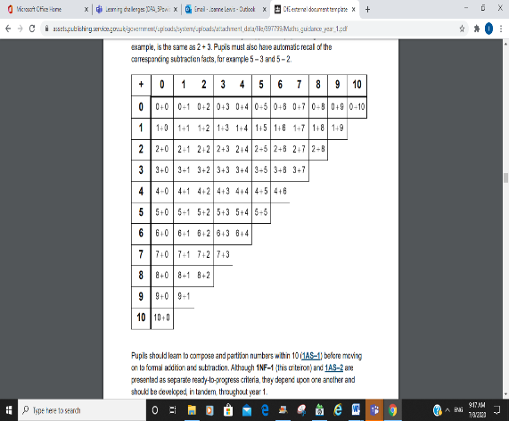
Maths | 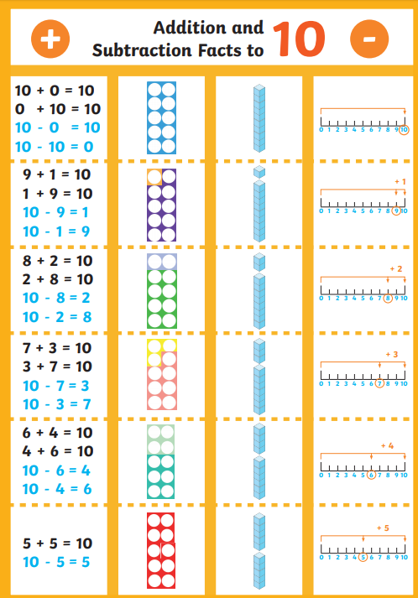 | Practice your addition and subtraction facts to 10. | Practice partitioning different 2 digit numbers in different ways:  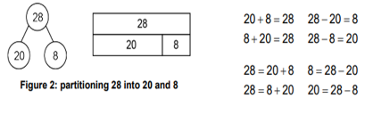
Life Skills challenge |   Dress yourself.   Tidy your toys. | Learn to fasten your shoelaces.  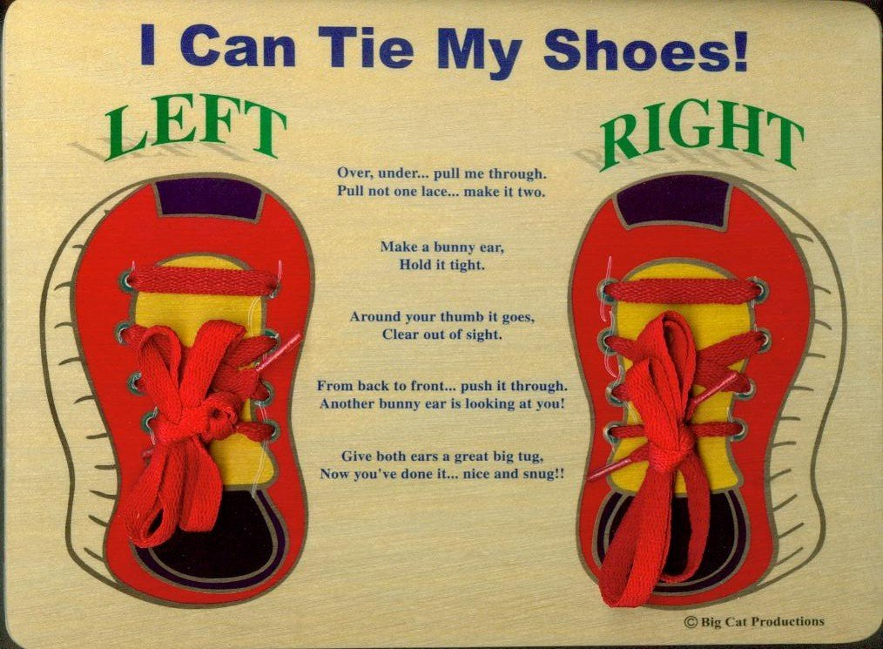  Set a table for a family dinner.   | Sort the recycling    Hang clothes out to dry.  

